YOUR PARTICIPATION

IN THE ENDOWMENT

PROGRAM WILL BE A

BLESSING TO YOU,

YOUR FAMILY,

YOUR CHURCH

AND YOUR GOD.

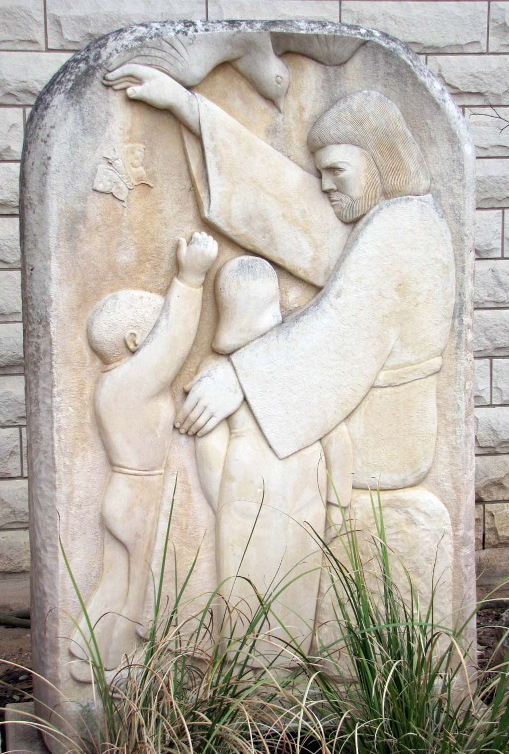

Mission Statement

Holy Ghost Lutheran

Endowment Fund

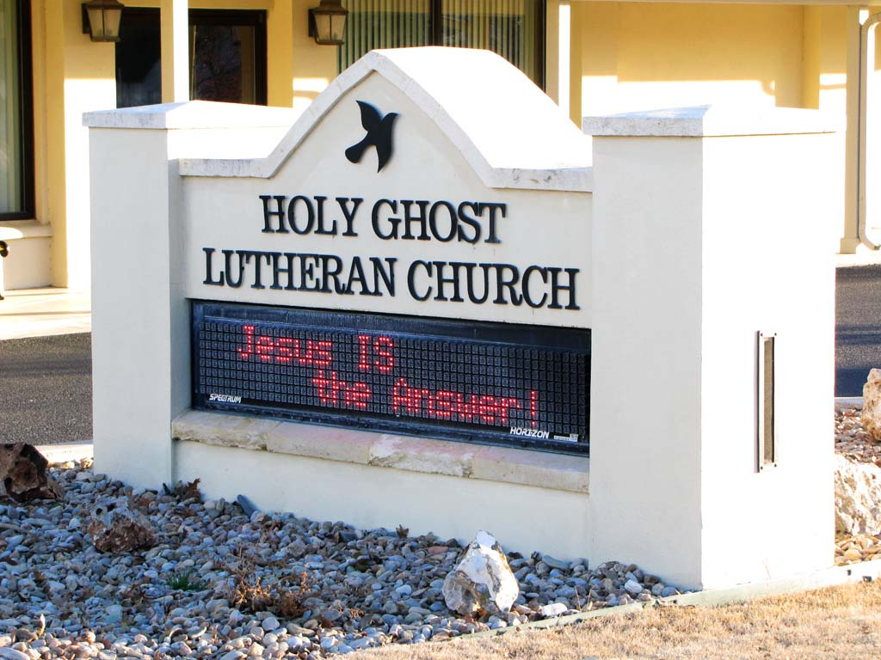

In as much as God calls us to “be and make disciples,” the Endowment Fund of Holy Ghost Lutheran Church of Fredericksburg, Texas, is dedicated to expanding our ministry beyond what would otherwise be possible through our regular tithes and offerings. Through a ministry of education, we will assist the congregation members in planning for faithful stewardship of special gifts and estate assets and provide a means through which a legacy can be created to minister to God’s people.

Holy Ghost Lutheran Church
109 E. San Antonio Street
Fredericksburg, Texas 78624
(830) 997-2288
(830) 997-7869 fax
E-mail: holyghost@austin.twcbc.com
Website: www.holyghostfbg.org

HOLY GHOST

LUTHERAN CHURCH

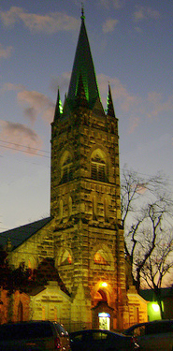

Endowment Fund

Being and Making Disciples
In Jesus’ Name!

WHAT IS THE HOLY GHOST LUTHERAN ENDOWMENT FUND?

It is a resource set up to receive and manage gifts for God’s work, creating a legacy of stewardship that can last for years.

It provides funds for ministry above and beyond the annual budget of Holy Ghost Lutheran.

It represents a partnership between donors
and Holy Ghost – a partnership based on stewardship. Donors, by supporting the endowment fund, are stewards to and for Holy Ghost Lutheran. By using the income generated by the Endowment, Holy Ghost Lutheran acts as a steward to and for its members and the community.

HOW DOES THE FUND WORK?

Contributions are received by gift and/or bequest. The principal remains intact and earns income. The income is used to meet Holy
Ghost Lutheran’s charitable goals and extraordinary needs, or for donor-specified purposes. Donors are able to support God’s work, while benefiting from tax advantages.



WHY MIGHT I GIVE?
- Personal Reasons – Desire to support Holy Ghost and other worthwhile organizations and projects.
- Family Reasons – Ability to support charitable causes and family at the same time.
- Spiritual Reasons – Desire to show thanks and praise to God.
- Financial Reasons – To include Income Tax, Estate Tax, and Capital Gains Tax benefits.

HOW MAY I GIVE?
There are a variety of ways to contribute. Here are just a few:

- Cash gifts
- Will bequests
- Beneficiary Designation gifts
(annuity, trust, IRA)
- Life Insurance gifts
- Investment gifts
(stocks, bonds, mutual funds, real estate)
- Memorials

IS THERE A WAY THAT I CAN GIVE TO THE ENDOWMENT FUND WHILE RETAINING THE INCOME FROM THAT ASSET DURING MY LIFETIME?

Yes, charitable life income agreements are designed to do just that.

Consultation with a competent financial professional is strongly encouraged when making planned giving arrangements.
HOW MUCH MAY I GIVE?

Your gifts can be any amount.

MAY I GIVE ON A REGULAR BASIS?

Yes, you may give monthly, yearly, or once
in a lifetime.

MAY I DESIGNATE WHERE THE INCOME FROM MY GIFT MAY BE SPENT?

Yes, subject to minimum requirements by Endowment Fund bylaws and acceptance
by the Endowment Fund Committee. Unrestricted gifts are encouraged because of the perpetual nature of the gift and the fact that future needs may change.

WHO WILL ADMINISTER THE ENDOWMENT FUND?

The Endowment Fund Committee will administer the fund according to the investment policy statement. The committee is comprised of five council-appointed members of Holy Ghost Lutheran, the Council Treasurer, one member from the Stewardship Team, and a Pastor. A professional investment manager may be engaged upon committee recommendation.

SHOULD I HAVE AN INTEREST IN

PARTICIPATING IN THE ENDOWMENT

FUND, WHO MAY I CONTACT FOR

MORE INFORMATION OR ASSISTANCE

IN GETTING STARTED?

Please call the church office for assistance.

